Core Group Kids!
A study through 2 Corinthians

Date: October 4th | Scripture to Read: 2 Corinthians 5:16-21
Questions to discuss with Kids | 1. How does someone become in Christ?  2. What happens when someone is in Christ? See verse 17.  3. What are some of the new things that happen to us when we are in Christ?
Craft Idea  Items Needed:  *Pipe cleaners, tissue paper, small piece of paper, markers  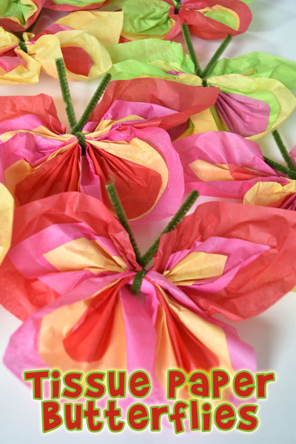  Craft Sample | New Creation Butterfly Craft- Just like a caterpillar becomes a new creation in the form of a butterfly, when we are in Jesus we become a new creation. Kids will make a butterfly craft using colored tissue paper squares and pipe cleaners. Give each kid 2 pieces of colored gift wrap tissue paper. Bunch the paper in the middle using your hand, next tie it with a pipe cleaner and form the pipe cleaner to be the antennas of the butterfly. Kids can write on the tissue paper or on a small piece of paper, “Therefore, if anyone is in Christ, he is a new creation…” 2 Cor. 5:17a. Attach the verse through the pipe cleaner.
Game Idea  Items Needed:  *Socks, Old stuff, New stuff | Old & New Sock Race- Give each kid a sock filled with old stuff; like used newspaper pieces, used aluminum foil or old leaves. Give each kid a small pile of new stuff; like new pennies, new candy or new napkins. On “Go” have the kids quickly empty their sock of the old stuff and then fill it with the new stuff. First kid done wins!
Got extra time? Here’s an idea—“Old things have passed away” Game- Share with the kids that when we are in Christ, old things have passed away! And now we are going to “Pass Away” trash into the trash can! Give each kid a pile of scratch paper. Have kids sit in a circle. Place a trash can in the center of the circle. On “Go” kids will make paper balls and throw the “Old things” into the trash can!

